**A WORK ON SIMPLE DEEP LEARNING**

**Pillars of Deep Learning:**

**Artificial neural networks(ANN):**

Artificial neural networks (ANNs) are inspired by the human brain, and they are made up of interconnected nodes that can learn to recognize patterns in data. ANNs are composed of the following components:

Input layer: The input layer is the first layer of an ANN, and it is where the data is fed into the network. The input layer is made up of a set of nodes, each of which represents a single feature of the data.

Hidden layers: The hidden layers are the layers that lie between the input layer and the output layer. The number of hidden layers in an ANN can vary, and the number of nodes in each hidden layer can also vary. The hidden layers are where the actual learning takes place.

Output layer: The output layer is the final layer of an ANN, and it is where the network's predictions are made. The output layer is made up of a set of nodes, each of which represents a single output of the network.

Weights: The weights are the values that connect the nodes in an ANN. The weights determine how much influence each node has on the output of the network. The weights are updated during training, and they are what allow the network to learn.

Bias: The bias is a value that is added to the output of each node. The bias helps to adjust the output of the node, and it can help to prevent the network from overfitting the training data.

Activation function: The activation function is a function that is applied to the output of each node. The activation function determines how the output of the node is used to calculate the output of the network. There are many different activation functions available, and the choice of activation function depends on the task that the network is being trained to perform.

ANNs are trained using a technique called backpropagation. Backpropagation works by calculating the error of the network's output, and then propagating the error back through the network to update the weights of the nodes. This process is repeated until the network converges, which means that the error of the network's output is minimized.

**TYPES OF ACTIVATION FUNCTIONS:**

some of the most common activation functions used in deep learning:

*Sigmoid*: The sigmoid function is a non-linear function that is often used in classification problems. The sigmoid function outputs a value between 0 and 1, which can be interpreted as the probability of a particular class.

*Tanh:* The tanh function is similar to the sigmoid function, but it outputs a value between -1 and 1. The tanh function is sometimes used in place of the sigmoid function because it has a steeper slope, which can help to improve the performance of the network.

*ReLU:* The ReLU function is a non-linear function that is often used in regression problems. The ReLU function outputs a value of 0 if the input is negative, and the output is equal to the input if the input is positive. The ReLU function is a very efficient function, and it can help to speed up the training of the network.

*Leaky ReLU:* The Leaky ReLU function is a variation of the ReLU function that outputs a small positive value if the input is negative. The Leaky ReLU function can help to prevent the network from dying, which is a problem that can occur with the ReLU function.

*Softmax:* The softmax function is a non-linear function that is often used in multi-class classification problems. The softmax function outputs a vector of probabilities, where each probability represents the probability of a particular class.

The choice of activation function depends on the task that the network is being trained to perform. For example, the sigmoid function is often used in classification problems because it can output a probability, while the ReLU function is often used in regression problems because it can output a continuous value.

Here is a table that summarizes the different activation functions and their uses:

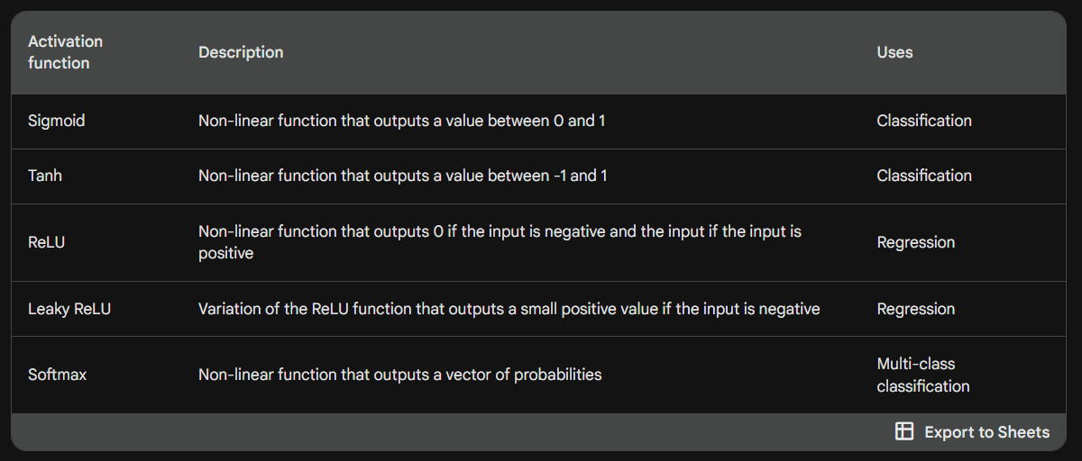

**BACKPROPAGATION:**

Backpropagation is an algorithm used to train artificial neural networks. It works by calculating the error of the network's output, and then propagating the error back through the network to update the weights of the nodes. This process is repeated until the network converges, which means that the error of the network's output is minimized.

Here is a more detailed explanation of how backpropagation works:

1.The network is first presented with a training example.

2. The network then outputs a prediction.

3. The error of the prediction is calculated.

4. The error is propagated back through the network.

5. The weights of the nodes are updated.

Steps 1-5 are repeated until the network converges.

Backpropagation is a very efficient algorithm, and it is one of the main reasons why deep learning has been so successful. However, backpropagation can be computationally expensive, especially for large networks.

Here are some of the benefits of using backpropagation:

Efficiency: Backpropagation is a very efficient algorithm, and it can be used to train large networks quickly.

Accuracy: Backpropagation can be used to train networks that are very accurate.

Generalization: Backpropagation can be used to train networks that generalize well to new data.

Here are some of the challenges of using backpropagation:

Computational expense: Backpropagation can be computationally expensive, especially for large networks.

Convergence: Backpropagation can be difficult to converge, and it may require a lot of iterations to reach a minimum error.

Overfitting: Backpropagation can be prone to overfitting, which means that the network may learn the training data too well and not generalize well to new data.

Overall, backpropagation is a powerful algorithm that can be used to train deep learning networks. However, it is important to be aware of the challenges of backpropagation before using it.

**LARGE DATASETS:**

Deep learning models require large datasets to train. These datasets can be used to train the network to recognize patterns in data that would be difficult or impossible to recognize with traditional machine learning techniques.

**OPTIMIZERS:**

An optimizer is a function or an algorithm that adjusts the attributes of a neural network, such as weights and learning rates, in order to reduce the losses. In other words, it helps the neural network learn from its mistakes and improve its accuracy over time.

There are many different optimizers available, each with its own advantages and disadvantages. Some of the most popular optimizers include:

Gradient descent: This is the most basic optimizer, and it works by adjusting the weights of the neural network in the direction of the negative gradient of the loss function.

Momentum: This optimizer adds a momentum term to the gradient descent update, which helps the network converge faster.

Adagrad: This optimizer adapts the learning rate for each weight in the neural network, which helps to prevent the network from getting stuck in local minima.

RMSProp: This optimizer is similar to Adagrad, but it uses a running average of the squared gradients to calculate the learning rate.

Adam: This is a newer optimizer that combines the advantages of Adagrad and RMSProp.

The choice of optimizer depends on the specific problem that the neural network is being trained to solve. For example, if the problem is very noisy, then an optimizer with momentum or Adam may be a good choice. If the problem is very smooth, then a simple gradient descent optimizer may be sufficient.

In general, optimizers are an essential part of training neural networks. They help the network learn from its mistakes and improve its accuracy over time. By choosing the right optimizer for the specific problem, you can improve the performance of your neural network

Here are some of the benefits of using optimizers in neural networks:

Improved accuracy: Optimizers can help neural networks learn more effectively, which can lead to improved accuracy.

Reduced training time: Optimizers can help neural networks converge faster, which can reduce the amount of time it takes to train them.

Improved generalization: Optimizers can help neural networks generalize better to new data, which can improve their performance on unseen data.

If you are interested in learning more about optimizers in neural networks, I recommend the following resources:

A Comprehensive Guide on Optimizers in Deep Learning: <https://www.analyticsvidhya.com/blog/2021/10/a-comprehensive-guide-on-deep-learning-optimizers/>

Machine Learning Optimization - Why is it so Important?: <https://www.seldon.io/machine-learning-optimisation>

Optimization in Deep Learning- Learn with examples: <https://www.e2enetworks.com/blog/optimization-in-deep-learning-learn-with-examples>

**NEGATIVE GRADIENT:**

In deep learning, a negative gradient is a vector that points in the direction of decreasing loss. Gradient descent is an optimization algorithm that uses negative gradients to update the parameters of a model in order to minimize loss.

When a model is trained using gradient descent, the algorithm starts with a random set of parameters and then updates the parameters in a small step in the direction of the negative gradient. This process is repeated until the loss is minimized.

The negative gradient is important because it tells the algorithm which way to update the parameters in order to minimize loss. If the gradient is positive, the algorithm will update the parameters in the direction of increasing loss. If the gradient is negative, the algorithm will update the parameters in the direction of decreasing loss.

Negative gradients are used in a variety of deep learning applications, including image classification, natural language processing, and speech recognition.

Here is an example of how negative gradients are used in image classification. Let's say we have a model that is trained to classify images of cats and dogs. The model has a set of parameters that control how it classifies images.

When we feed an image of a cat to the model, the model will output a probability that the image is a cat. If the probability is high, the model will classify the image as a cat. If the probability is low, the model will classify the image as a dog.

The model's parameters are updated using negative gradients. If the model predicts that an image is a cat, but it is actually a dog, the gradient will be negative. This tells the algorithm to update the parameters in the direction of decreasing the probability that the model will predict that an image is a cat.

This process is repeated for many images, and the model's parameters are updated gradually. Over time, the model will learn to classify images more accurately.

**LOSS FUNCTION:**

In deep learning, a loss function is a mathematical function that measures the difference between the predicted output of a model and the actual output. The goal of the deep learning model is to minimize this loss function.

Loss functions are used in a variety of deep learning applications, including image classification, natural language processing, and speech recognition.

Here are some of the most common loss functions used in deep learning:

Mean squared error (MSE): This is a loss function that measures the average squared difference between the predicted output and the actual output. MSE is a good choice for regression tasks, where the model is trying to predict a continuous value.

Cross-entropy loss: This is a loss function that measures the difference between the predicted probability distribution and the actual probability distribution. Cross-entropy loss is a good choice for classification tasks, where the model is trying to predict a discrete value.

Huber loss: This is a loss function that is a combination of MSE and L1 loss. Huber loss is less sensitive to outliers than MSE, making it a good choice for tasks where outliers are common.

The choice of loss function depends on the specific task that the model is trying to accomplish. For example, if the model is trying to predict a continuous value, such as the price of a stock, then MSE would be a good choice. If the model is trying to predict a discrete value, such as whether or not a person will click on an ad, then cross-entropy loss would be a good choice.

Loss functions are an important part of deep learning. They help to measure the performance of the model and guide the optimization process. By choosing the right loss function, you can help to ensure that your model learns to perform the task that you want it to perform.

**REGULARIZTION:**

Regularization is a technique used in machine learning and deep learning to prevent overfitting. Overfitting occurs when a model learns the training data too well and is unable to generalize to new data. Regularization helps to prevent overfitting by adding a penalty to the loss function that encourages the model to be simpler.

There are many different regularization techniques, but some of the most common include:

L1 regularization: This technique adds a penalty to the loss function that is proportional to the absolute value of the model's parameters. This encourages the model to have smaller parameters, which can help to prevent overfitting.

L2 regularization: This technique adds a penalty to the loss function that is proportional to the square of the model's parameters. This also encourages the model to have smaller parameters, but it is less harsh than L1 regularization.

Dropout: This technique randomly drops out some of the neurons in the model during training. This forces the model to learn to rely on more than just a few neurons, which can help to prevent overfitting.

Regularization is an important technique in deep learning. It can help to prevent overfitting and improve the generalization performance of the model.

Here are some of the benefits of using regularization in deep learning:

Improved generalization performance: Regularization can help to prevent overfitting, which can improve the generalization performance of the model. This means that the model will be better able to predict new data that it has not seen before.

Reduced model complexity: Regularization can help to reduce the complexity of the model. This can make the model easier to understand and interpret.

Increased training stability: Regularization can help to increase the training stability of the model. This means that the model will be less likely to diverge during training.

Here are some of the drawbacks of using regularization in deep learning:

Can reduce model accuracy: In some cases, regularization can reduce the accuracy of the model. This is because regularization can prevent the model from learning the training data as well as it could without regularization.

Can be computationally expensive: Regularization can be computationally expensive, especially for large models.

Can be difficult to tune: The amount of regularization that is used can be difficult to tune. If too much regularization is used, the model can become too simple and will not be able to learn the training data as well. If not enough regularization is used, the model can become too complex and will overfit the training data.

Overall, regularization is a powerful technique that can be used to improve the generalization performance of deep learning models. However, it is important to be aware of the potential drawbacks of regularization before using it.